Quantified Student

Attendance prototyping

Thijmen Brand (480490)



# Table of Contents

**Table of Contents** **2**

**Version History** **3**

**Introduction** **4**

**Chapter** **5**

**Conclusion** **6**

# Version History

|  |  |  |  |
| --- | --- | --- | --- |
| Date | Version | Author | Comment |
| 08-11-2022 | 0.1 | Thijmen Brand |  |
|  |  |  |  |

# Introduction

One important data source within the quantified student dashboard the attendance. This can be a valuable and meaning full source. We have already researched in which ways we can gather this data and the result of this paper was that it was easiest to poll the location of a phone and compare that to a radius within a school building. In document will outline the prototype process of this feature.

# Prototype objectives

For this prototype we want to find out if what we had researched and in mind does actually work. It has to work always in the condition that the phone’s location setting is turned on and the application has access to this setting. Then it has to save the users’ attendance status every 30 minutes accurately.

## Plan

a react native application will be made because it is easy and works fast. Then a background service will be made which periodically polls the users’ location. Then if this location is inside a set circle attendance status will be true, else it will be false. This data then is saved on the device in order to test it over a longer period.

## Execution

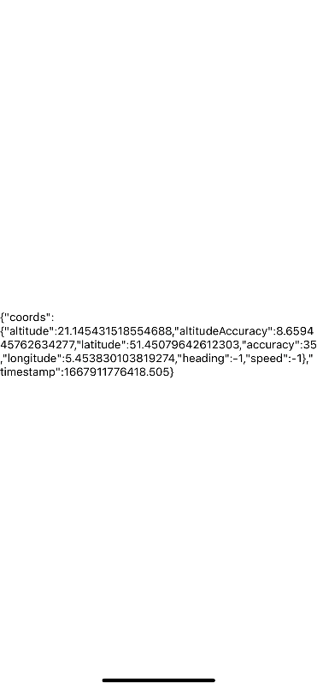I began with getting familiar with the framework and I made the current users’ location show on the screen. With this I got familiar with permissions. After I got this simple thing figured out I continued with the geofencing part. Luckily there is a standard library to do this which works by just providing the latitude, longitude and a radius for the fence and the library will then return a callback when you enter or left this circle. At first this didn’t work properly and I do not completely know why it didn’t. After tweaking some things in configuration it worked.

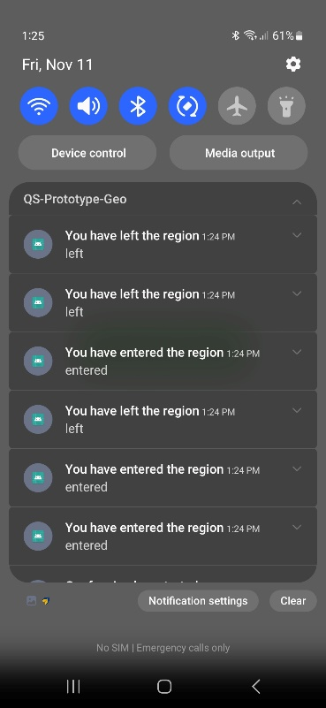So then I could use geofencing. But only when the application is open because that where the only permissions I had. When I tried to do it in the background it got bad. I got a lot of errors saying I did not have the correct permissions. After again a lot of head ache and tweaking things in the configuration I got this to work too.

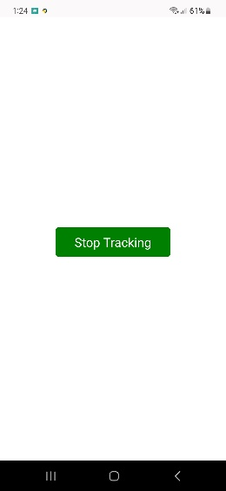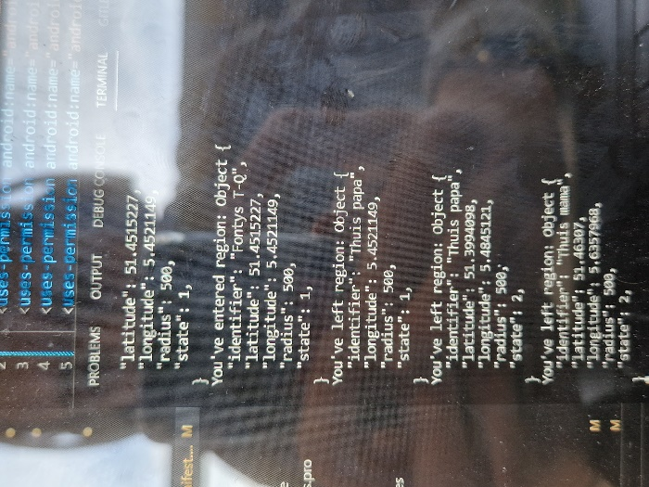So now I have a very simple app which has a button. When you click it, it starts with tracking you an notifying you every time you enter of leave the given area.

# Conclusion

After having tested this simple geofencing app I came to the conclusion that this is a viable option to track students’ attendance. Every time a student enters or leaves a school location this can be send to the api which then saves this information. This process runs entirely on the background an doesn’t require any actions by the users besides giving permissions.